**Calculator Using Arduino UNO**

**Description:**

This Project is to design **Calculator** using **Arduino UNO** board, **4x4 Keypad** and a **LCD display**. This calculator do basic mathematical operations like **Addition (+), Subtraction (-), Multiplication (x),** and **Division (/)**. When the user enters the operands in the LCD and **based on the operator** the **operation** need to be **performed** (i.e. when user enters operator **“+” in the keypad** then **addition operation** need to be performed and follows…). The calculator will take **only two operands** and **single operator** at a time. The calculator takes **recent two operators and recent operand** only.

**Block Diagram:**

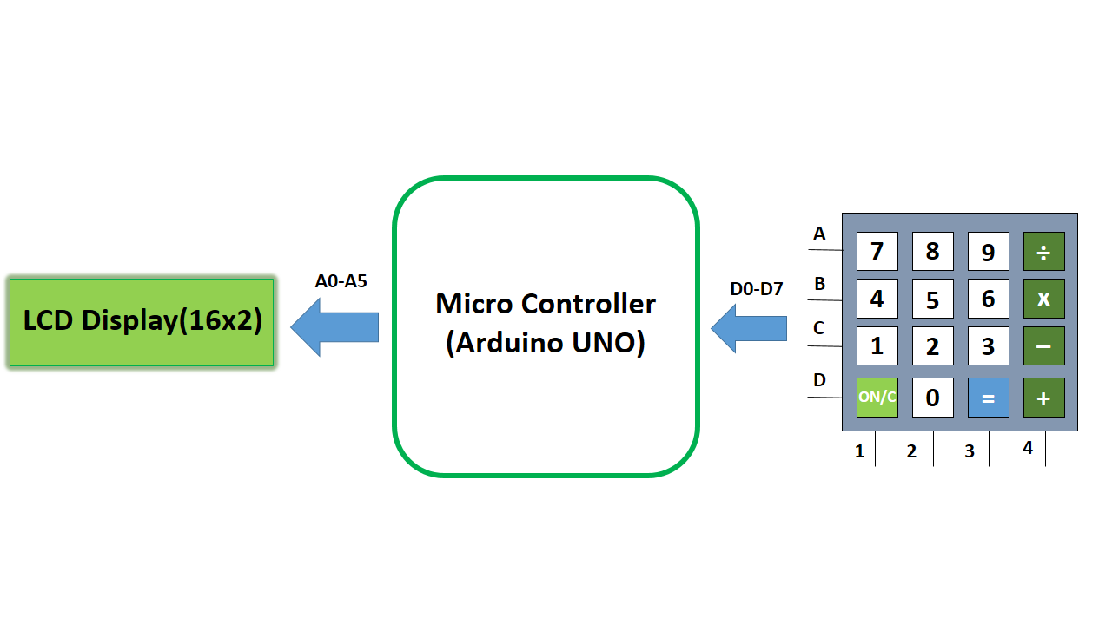

**Inputs and Outputs:**

|  |  |  |  |  |  |  |
| --- | --- | --- | --- | --- | --- | --- |
| **S.No** | **Description** | **Name** | **Type** | **Data Direction** | **Spec** | **Remarks** |
| 1 | KeyPad Row1 Pin | A | INP | DI | 5VDC | Active High |
| 2 | KeyPad Row2 Pin | B | INP | DI | 5VDC | Active High |
| 3 | KeyPad Row3 Pin | C | INP | DI | 5VDC | Active High |
| 4 | KeyPad Row4 Pin | D | INP | DI | 5VDC | Active High |
| 5 | KeyPad Column 1 Pin | 1 | INP | DI | 5VDC | Active High |
| 6 | KeyPad Column 2 Pin | 2 | INP | DI | 5VDC | Active High |
| 7 | KeyPad Column 3 Pin | 3 | INP | DI | 5VDC | Active High |
| 8 | KeyPad Column 4 Pin | 4 | INP | DI | 5VDC | Active High |
| 9 | LCD Reset Pin | RS | OUT | DO | 5VDC | Active High |
| 10 | LCD Enable Pin | E | OUT | DO | 5VDC | Active High |
| 11 | LCD Data Pin 1 | D4 | OUT | DO | 5VDC | Active High |
| 12 | LCD Data Pin 2 | D5 | OUT | DO | 5VDC | Active High |
| 13 | LCD Data Pin 3 | D6 | OUT | DO | 5VDC | Active High |
| 14 | LCD Data Pin 4 | D7 | OUT | DO | 5VDC | Active High |

**Flow Chart:**

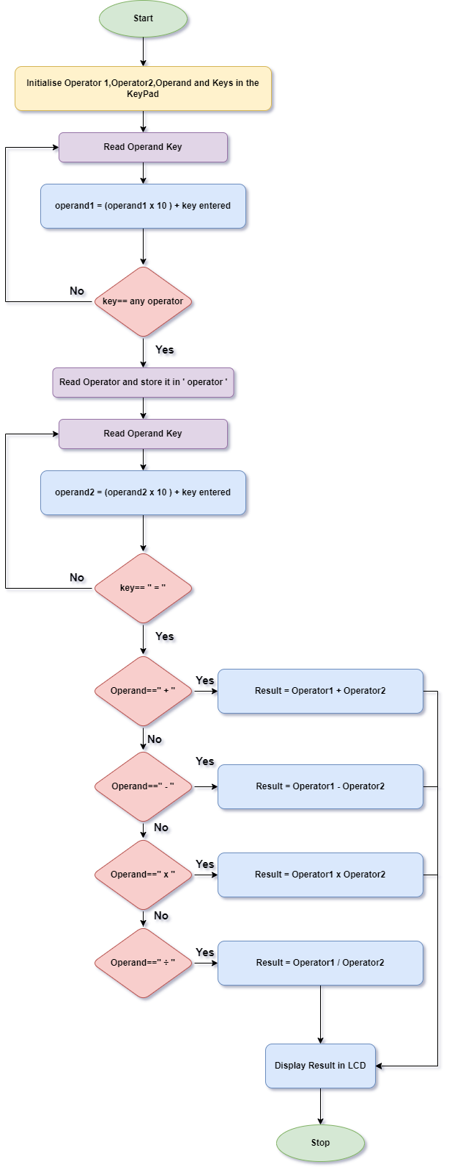



**The END**